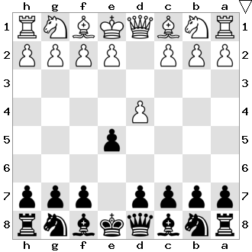

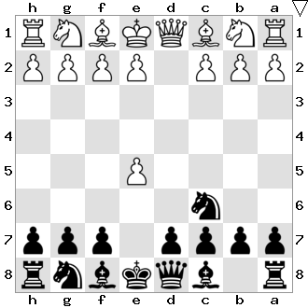

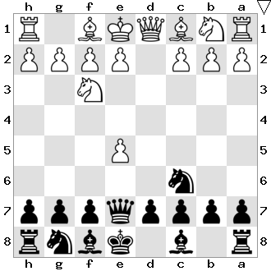

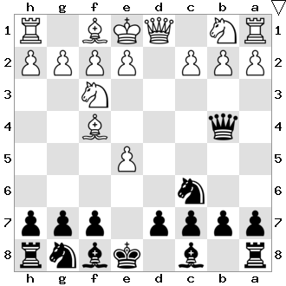

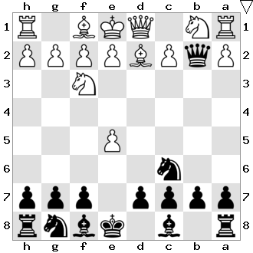

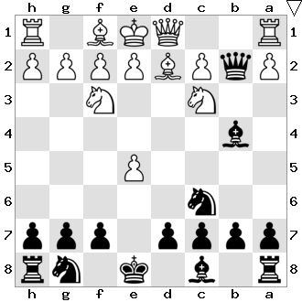

** GAMBIT ENGLUND**

|  |  |  |  |  |
| --- | --- | --- | --- | --- |
|  |  |  |  | **1.d4 e5** |
|  | **2.d5** Fc5 | **2.e4** exd4 | **2.c3** exd4 | **2.dxe5 Cc6** |
| **3.Cf3** d6 | 3.e4 a5 | 3.Dxd4 Cc6 | 3.cxd4 d5 |  |
| 4.e4 f5 | 4.Dg4 ?Cf6 |  |  |  |
|  | 5.Dxg7 Fxf2+ |  |  |  |
|  | 6.Rxf2 Tf8 ! |  |  |  |
|  |  |  |  |  |
|  |  | **3.Ff4** De7 |  | **3.Cf3 De7** |
|  |  |  |  |  |
|  |  | **4.Fg5** Db4+ | **4.Dd5** f6 | **4.Ff4 Db4+** |
|  |  |  | 5.exf6 Cxf6 |  |
|  |  |  | 6.Db3 d5 |  |
|  |  |  |  |  |
|  |  | **5.Cc3** Dxf4 | **5.Dd2** Dxb2 | **5.Fd2 Dxb2** |
|  |  | 6.Cd5 De4 |  |  |
|  |  | 7.Cxc7+ Rd8 |  |  |
|  |  | 8.Cxa8 Cb4 |  |  |
|  | 9.Cd4 ? Dxd4 | 9.Tc1 Cxa2 |  |  |
|  | 10.Dxd4 Cxc2+ | 10.Ta1 Cb4 = |  |  |
|  | 10.R ? CxD |  |  |  |
|  |  |  |  |  |
|  |  |  | **6.Fc3 ?** Fb4 | **6.Cc3 Fb4** |
|  |  |  | 7.Dd2 Fxc3 |  |
|  |  |  | 8.Dxc3 Dc1 # |  |
|  |  |  |  |  |
|  | **7.Cb5** Fxd2+ |  | **7.Cd5** Fxd2+ | **7.Tb1 Da3** |
|  |  | 8.Cxd2 Cb4 | 8.Rxd2 Rd8 |  |
|  |  |  |  |  |
| **8.Txb4** Cxb4 |  | **8.Cb5** Da5 | **8.Cd5** Fa5 | **8.Tb3 Da5** |
|  |  | 9.Cxc7+ Dxc7 | 9.Fxa5 Dxa5+ |  |
|  | **10.Fxb4?** Cxb4 | 10.Txb4 Cxb4 | 10.Dd2 Dxd2+ |  |
|  | 11.Txb4 Dc3+ |  |  |  |
|  | 12.Dd2 Da1+ |  |  |  |
|  | = |  |  |  |
|  |  |  |  | **9.a3 Fxc3** |
|  |  |  |  | **10.Fxc3 Dc5** |
|  |  |  |  | **11.e3 Cge7** |
|  |  |  |  | **12. Cg6** |
|  |  |  |  | **13. Cgxe5** |
|  |  |  |  |  |
|  |  |  |  |  |
|  |  |  |  |  |
|  |  |  |  |  |
|  |  |  |  |  |

Arrangement : René Maestre agrée F.F.E   
pour l’Échecs Club de Villeurbanne   
Destination : débutants et intermédiaires